A Course Project Report

On

MECHATRONICS
TEMPERATURE CONTROL OF A CLOSED CONTAINER

Submitted by
Jayston Menezes (201735)
Shefin Airly (201764)
Anthony D’souza (201718)
Tanay Iyer (201726)

GUIDE
PROF. GIRISH DALVI
(Assistant Professor)

DEPARTMENT OF MECHANICAL ENGINEERING
FR. CONCEICAO RODRIGUES INSTITUTE OF TECHNOLOGY,
VASHI


Academic Year: 2019 – 2020 (F.H. 2020)
Aim:

To maintain the temperature inside a closed container within a certain range using Arduino Microcontroller.

Objectives:
1) The temperature of the closed container will be maintained within the range of 30 ºC to 40 ºC.
2) The heating element with start when the temperature is less than or equal to 30
o
C and will remain in the ON state till the temperature reaches 40 ºC.
3) At 40 ºC, the heating element will turn OFF and the cooling element will start functioning.
4) The cooling element will remain in the ON state till the temperature reaches 30
o
C, at which point it will turn OFF and the heating element will turn ON again.

Project Description:

The volume of the entire wooden container is 29cm x 29cm x 15cm. A hole is made on the side of the container to place the cooling element. The DHT sensor (temperature sensing element) senses the temperature inside the closed container. If the temperature is less than or equal to 30 ºC, the Arduino signals the bulb (heating element) to switch ON. Heat emitted from the bulb is circulates through the fixed volume of the container by natural convection. The bulb remains in the ON state till the temperature in the container reaches 40 ºC. When the DHT sensor senses the temperature inside the container as 40 ºC, two signals are passed out from the Arduino i.e. one to switch OFF the bulb and second to switch ON the fan. The fan (cooling element) removes out the warm air from the inside of the closed container. The fan remains in the ON state till the temperature reaches 30 ºC. Once the DHT sensor detects the temperature as 30 ºC, two signals are sent out from the Arduino i.e. one to switch OFF the fan and second to switch ON the bulb. The bulb then starts increasing the temperature. The cycle goes on continuously until the entire operating system is switched OFF. The LCD (display device) displays the temperature detected by the DHT sensor at every stage.

Specification of Components:

Sr. No. | Component | Specifications
1. | Arduino Microcontroller | ATMega328p (5V operating voltage)
2. | DHT sensor | Operating range: 0 ºC to 50 ºC
3. | Bulb | 230V 100W AC
4. | Fan | Supply voltage: 12VDC Speed: 3000RPM
5. | Relay | Trigger Voltage (Voltage across coil): 5V DC Maximum AC load current: 10A @ 250/125V AC
6. | LCD Display | Operating Voltage: 4.7V to 5.3V Alphanumeric LCD display module 16×2 LCD
7. | Potentiometer | Shaft Type 10K Ohms 5W Power
8. | Battery | 9V
9. | Power Bank | 5220 mAh
10. | LM7805 | Input voltage- 7V to 35V  Output voltage: - 5.2V

Connection Diagram & Explanation:

A DHT sensor is placed in the container which is passed through the top plate. An Arduino is mounted on the top of the plate. The DHT sensor is connected to the Arduino for obtaining the temperature readings. An AC bulb is placed inside the container which is connected to relay for conversion of AC to DC. The relay is connected to the Arduino for maintaining the state of the Bulb as well as to an AC Supply for continuous input. A fan is placed on the hole made on the side of the container. This fan is connected to the Arduino for controlling its state. An LCD is mounted on the top plate of the container. The LCD is interfaced with the Arduino and DHT sensor to display the temperature inside the container and the pulse width applied to the fan (fan speed). A Potentiometer is connected to the LCD to vary its brightness. A breadboard is also mounted on the top plate to ease up the connections of different sensors and devices. A power bank is used to supply power to the Arduino thus eliminating the requirement of a Laptop USB Port as the Hardware gets damaged when an Ac appliance would be connected to the Laptop. A battery of 9 Volts is used to separate power the LCD so that it displays with maximum brightness. However, the operational voltage of the LCD is 5V, hence we use a LM7805 voltage regulator module which regulates the output voltage to 5V. The entire setup is thus mounted on the container, making it portable and easy to carry.

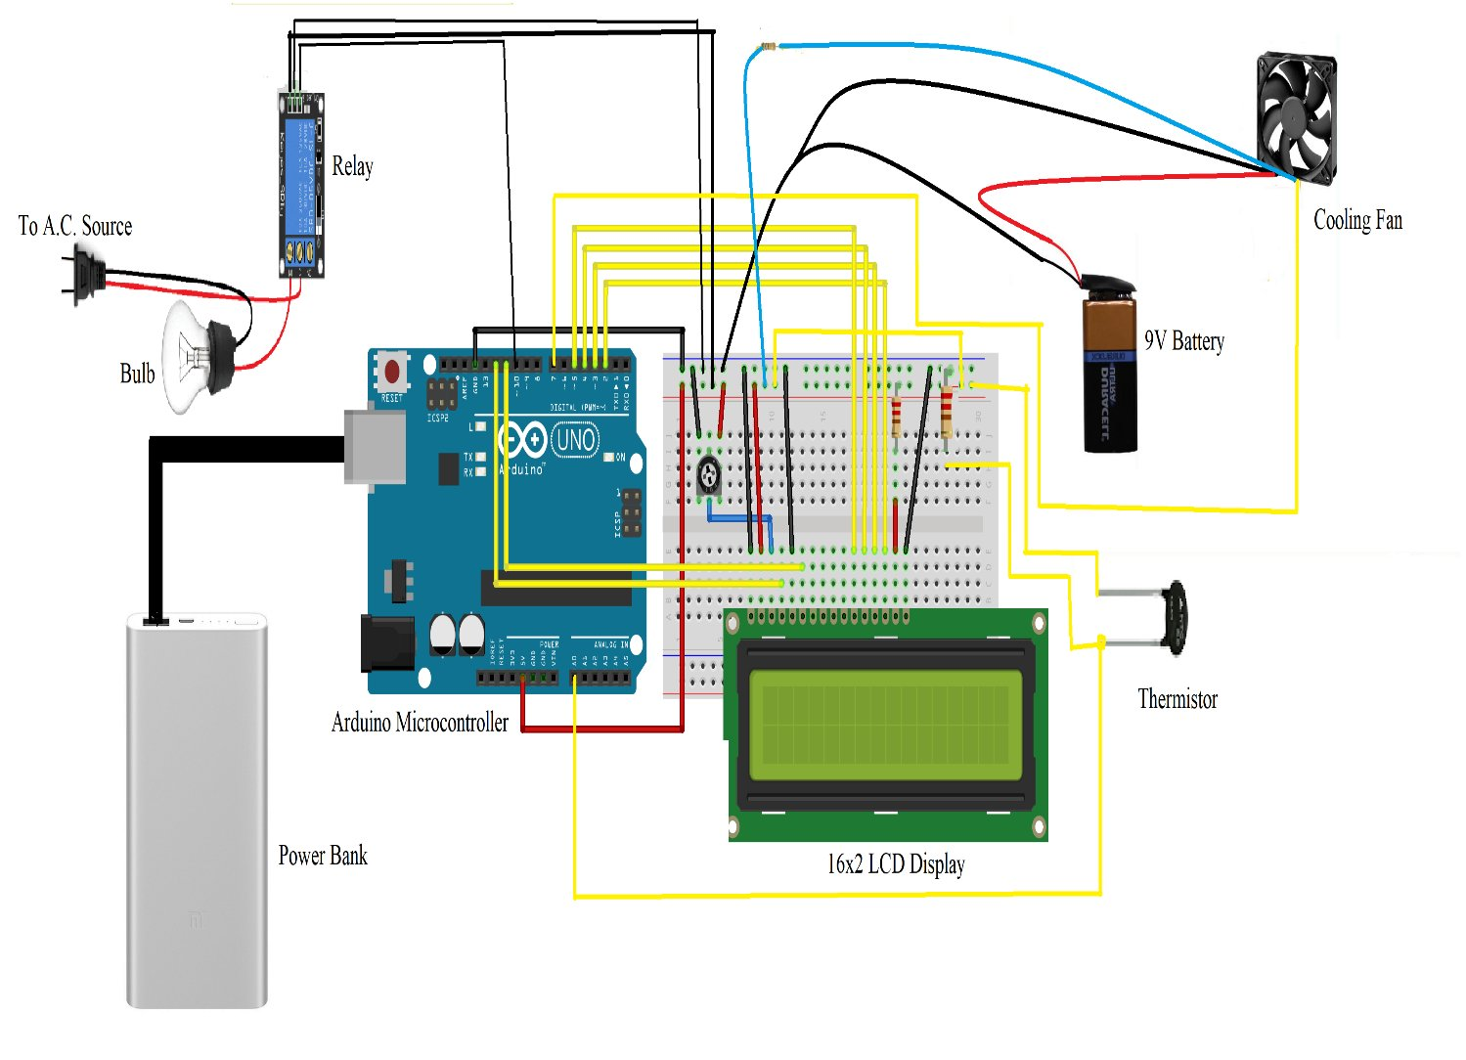
Photograph:

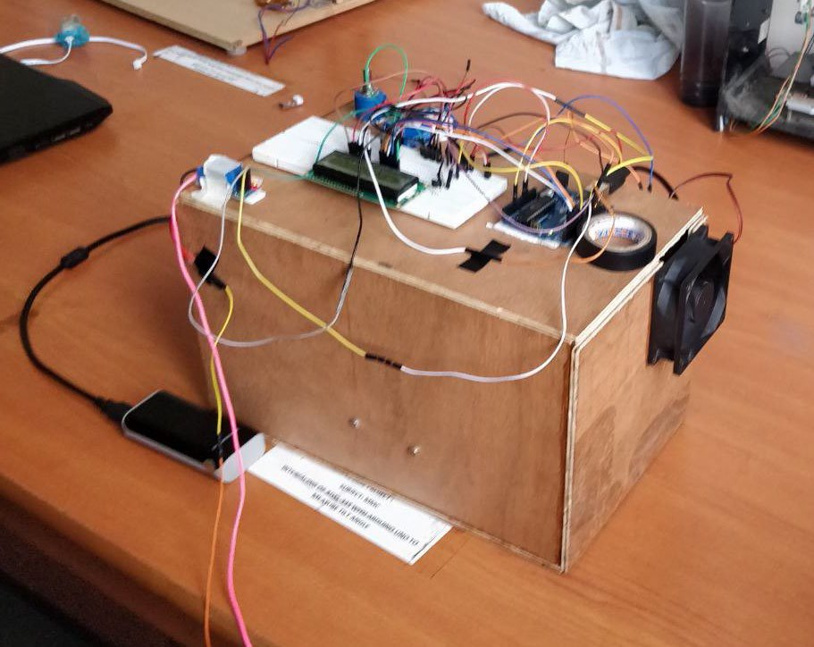
Cost of Project:
Sr.no | Component | Quantity | Cost (Rs.)
1. | Arduino Microcontroller | 1 | 542
2. | Thermistor | 1 | 30
3. | Bulb | 1 | 60
4. | PC Fan | 1 | 335
5. | Relay | 1 | 50
6. | LCD Display | 1 | 99
7. | Battery | 1 | 20
8. | Power Bank | 1 | 250
9. | Potentiometer | 1 | 10
10. | Wires | 40 | 75
Total |  | 49 | 1471/-
Conclusion:
The project setup was assembled by the team and was tested after uploading the Arduino Code. With few trial runs and final approval from the Project Guide, temperature control inside the wooden container was achieved successfully. Due to gaps present at the edges of the container as well as the hole provided for the fan, the heating process was slower compared to the cooling process. Thus, with a budget under Rs. 1500/- and work time of 2-3 days, temperature control within a certain range can be achieved with sufficient accuracy.

